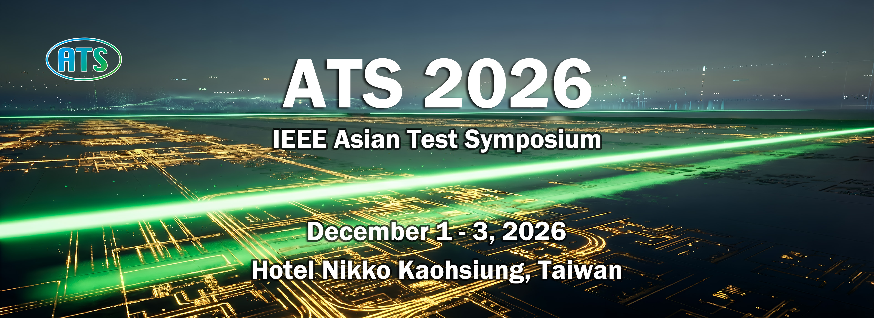
SPECIAL SESSION PROPOSAL
Complete all applicable fields and delete bracketed instructions before submission. The completed proposal must not exceed two A4 pages.
1. Proposed Session Title
[Enter the proposed session title]
2. Scope and Main Topic(s)
[Identify the scope and principal topic(s) of the session]
3. Session Abstract (150-200 words)
[Enter a 150-200-word abstract summarizing the proposed session]
4. Objectives and Relevance to ATS 2026
[Explain the session objectives and relevance to ATS 2026]
5. Timeliness, Impact, and Expected Interest
[Explain alignment with timely, emerging, or high-impact topics in test, reliability, and dependable systems, and why the session will attract broad ATS community interest]
6. Session Organizer(s) and Moderator
Provide names, professional titles, affiliations, contact information, and brief biographies. Each organizer's brief biography must describe relevant experience in organizing special sessions, panels, tutorials, workshops, or related activities at international conferences or professional events.
Role | Full Name & Professional Title | Affiliation | Contact Information | Brief Biography / Relevant Experience
Primary Organizer | [Enter information] | [Enter information] | [Enter information] | [Enter information]
Co-organizer | [Enter information] | [Enter information] | [Enter information] | [Enter information]
Moderator | [Enter information] | [Enter information] | [Enter information] | [Enter information]
The moderator may also serve as one of the invited speakers.
7. Prospective Speakers and Presentations
Provide at least three prospective speakers. Add another speaker profile if needed.
Prospective Speaker 1
Full Name & Professional Title | Affiliation & Contact Information | Tentative Presentation Title
[Enter information] | [Enter information] | [Enter information]
Two-sentence biography: [Enter biography]

Prospective Speaker 2
Full Name & Professional Title | Affiliation & Contact Information | Tentative Presentation Title
[Enter information] | [Enter information] | [Enter information]
Two-sentence biography: [Enter biography]

Prospective Speaker 3
Full Name & Professional Title | Affiliation & Contact Information | Tentative Presentation Title
[Enter information] | [Enter information] | [Enter information]
Two-sentence biography: [Enter biography]

8. Proposed Session Structure and Expected Contributions
[Describe the planned format (technical presentations, panel discussion, embedded tutorial, or other interactive activities) and the expected contributions]
9. Proposed Duration and Detailed Schedule
Total session duration must be 60-90 minutes. Technical presentations should normally be approximately 20-30 minutes. The schedule must indicate the time allocated to each presentation, discussion, Q&A session, and interactive activity.
Start Time | Duration | Activity / Presentation | Speaker / Moderator | Format
[Enter] | [Enter] | [Enter] | [Enter] | [Enter]
[Enter] | [Enter] | [Enter] | [Enter] | [Enter]
[Enter] | [Enter] | [Enter] | [Enter] | [Enter]
[Enter] | [Enter] | [Enter] | [Enter] | [Enter]
[Enter] | [Enter] | [Enter] | [Enter] | [Enter]
Total duration: [60-90 minutes]
Participation Confirmation
By submitting this proposal, the organizers, moderator, and prospective speakers confirm their intention to register for and participate in ATS 2026 if the session is accepted. At least one organizer will coordinate the session, communicate with the ATS 2026 Organizing Committee, and ensure timely submission of all required publication materials.
Publication information if accepted: Organizers and speakers will be invited to prepare either one consolidated paper of up to 10 pages, excluding references, or three individual papers of up to 4 pages each, excluding references. All papers must comply with ATS 2026 formatting, review, registration, and publication requirements.
Submission Information
Proposal deadline: August 31, 2026 | Notification of acceptance: September 13, 2026
Submit through the ATS 2026 EasyChair submission system. After clicking New Submission, select the track: ATS 2026 Special & Innovative Session Proposals. Complete the submission form and upload the proposal document. Please ensure that this track is selected. Submissions entered under the Late-Breaking Results (LBR) Track will not be treated as Special Session or Innovative Practices Session proposals. Submissions by email will not be accepted.
Technical program inquiries: Prof. Tong-Yu Hsieh, TPC Chair, ATS 2026 | tyhsieh.nsysu@gmail.com

